TABLEAU HOMEWORK

1.3 What are the highest and lowest regions?

1.4 Label sheet 1 Prevalence of Obesity by Region

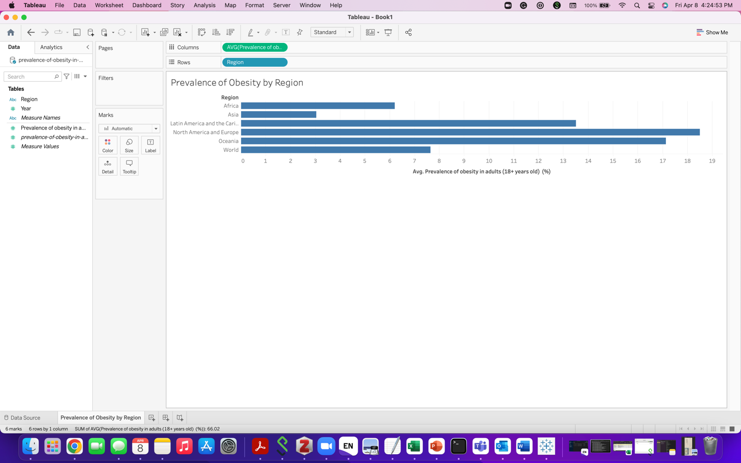



Highest region with average prevalence of obesity: North America and Europe (18.50)

Lowest region with average prevalence of obesity: Asia (3.05)

* 1. Label sheet 2 Prevalence of Obesity by Year

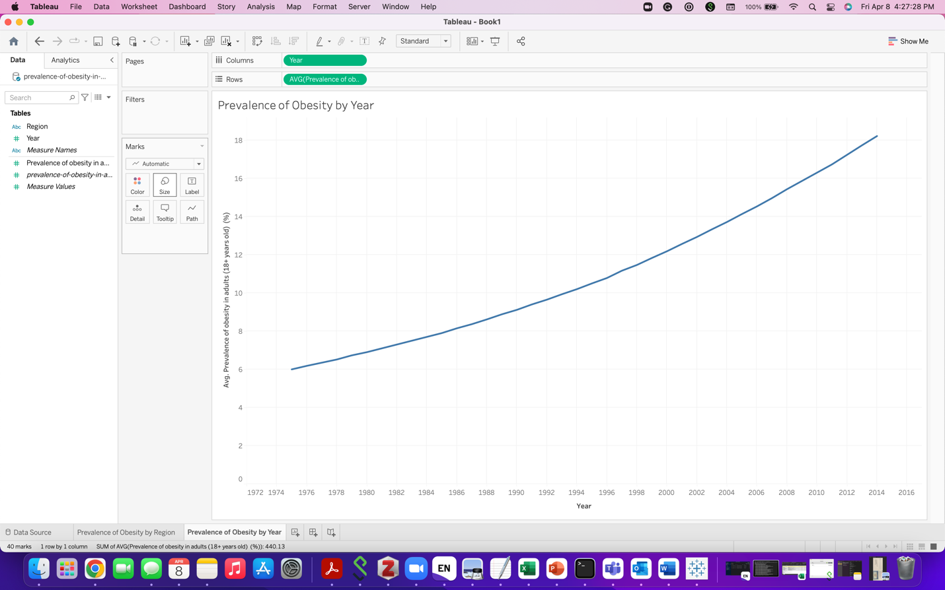



2.6 What is the trend?

There is linear increase in the average prevalence of obesity from 1975 to 2016

4. DASHBOARD- TUMMALA’S Obesity dashboard

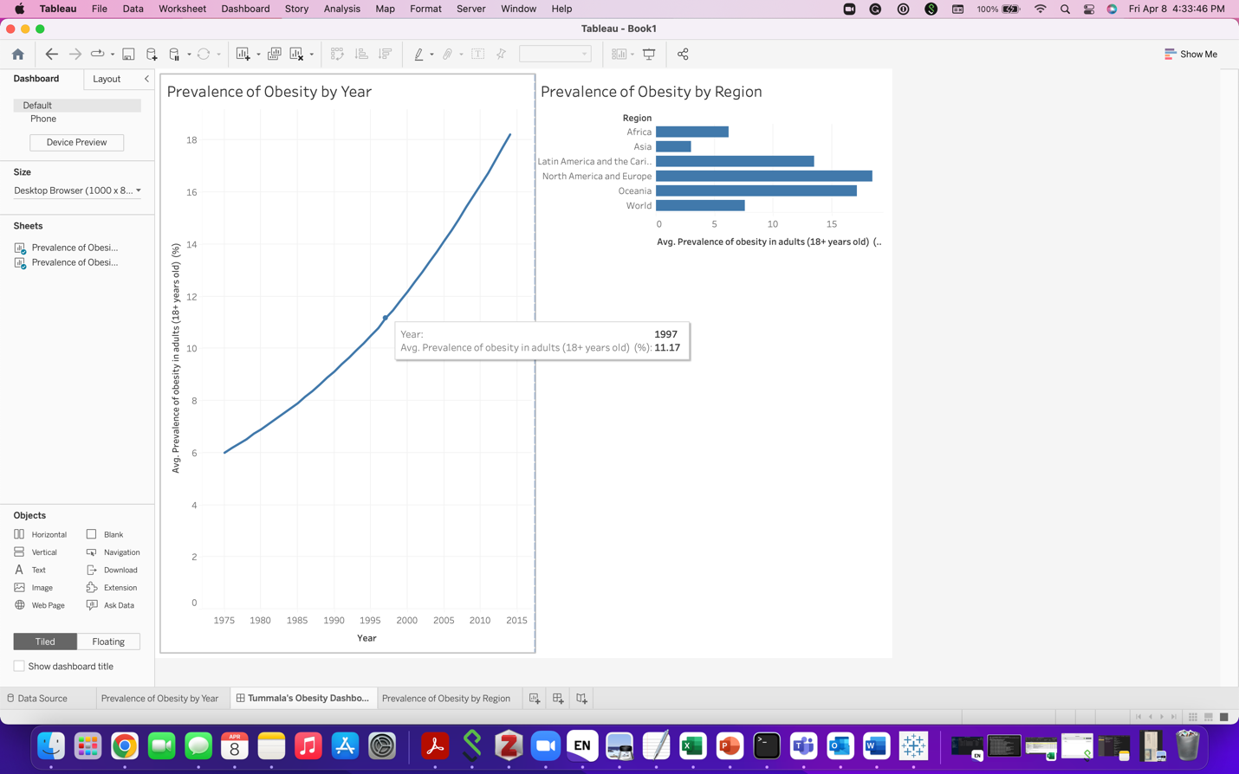

CONNECTICUT- PART -II

1.Create a dashboard that tells a story of what type of person dies from accidental overdoses and from what drugs.

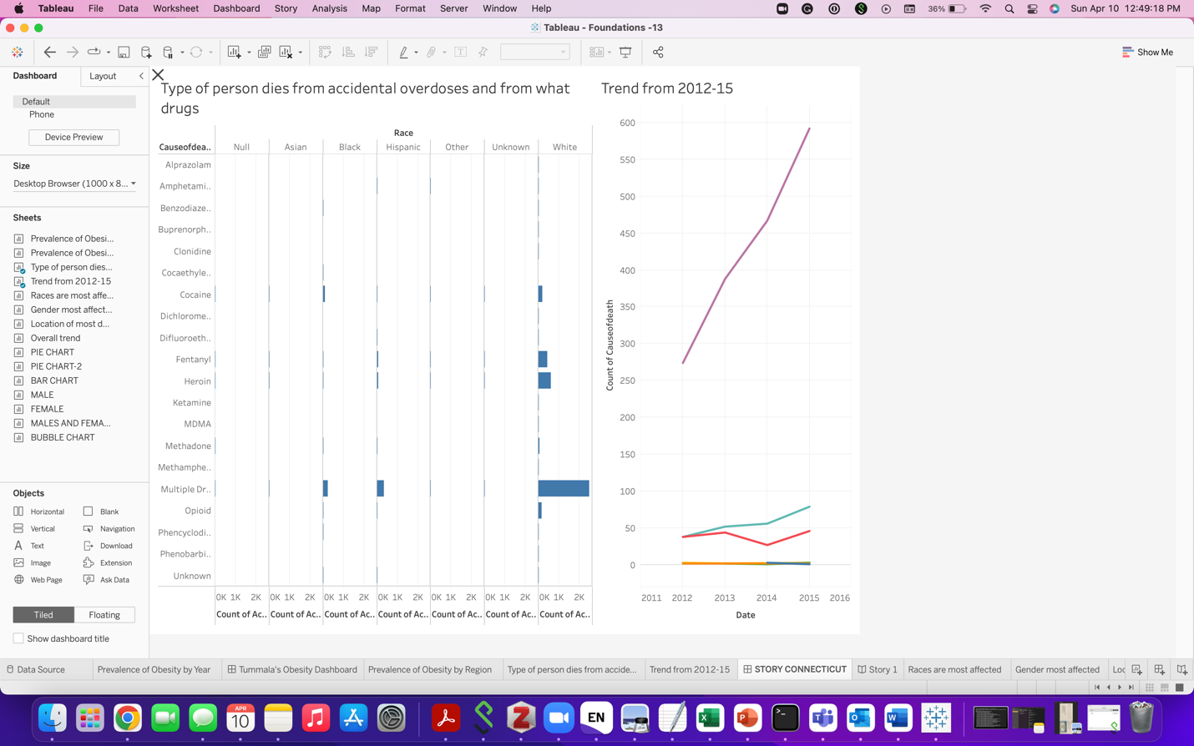

1.1 What is the trend from 2012-2015?

From 2012 to 2015 there is increase in the count of causes of death from 355 to 726 respectively.

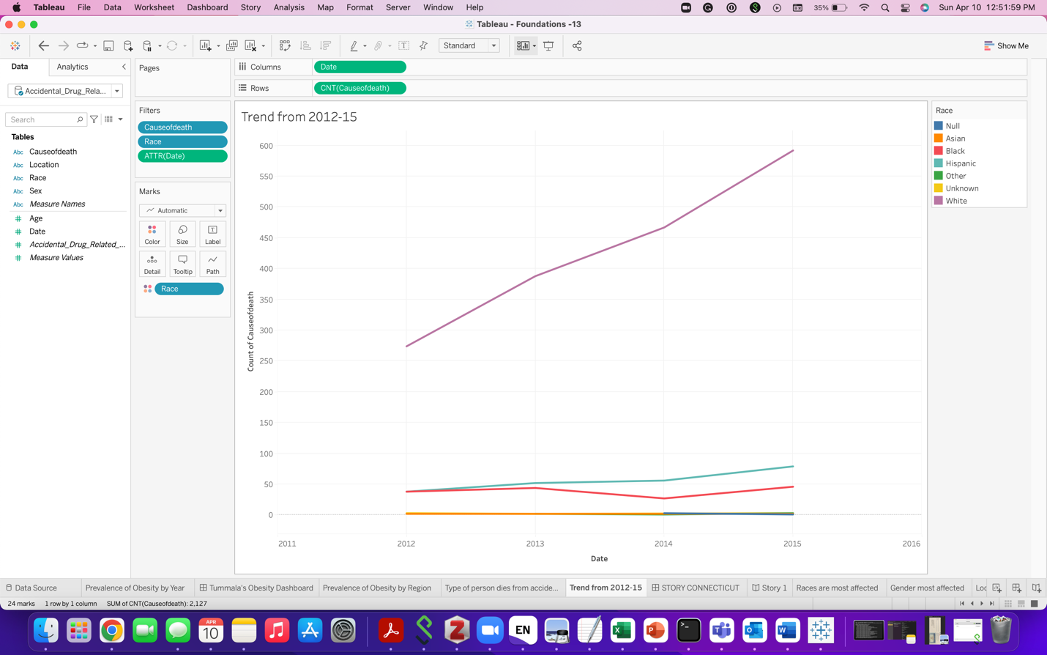

1.2 What problems did you encounter?

As the data contains null and unknow values, it made reading and analyzing the data difficult.

 2.1Are there still some that should be combined?

For the given dataset, all the variables are distinct and there is no need for combination or exclusion of variables.

2.2.1. What races are most affected?

Whites are most affected with Multiple Drug Toxicity.

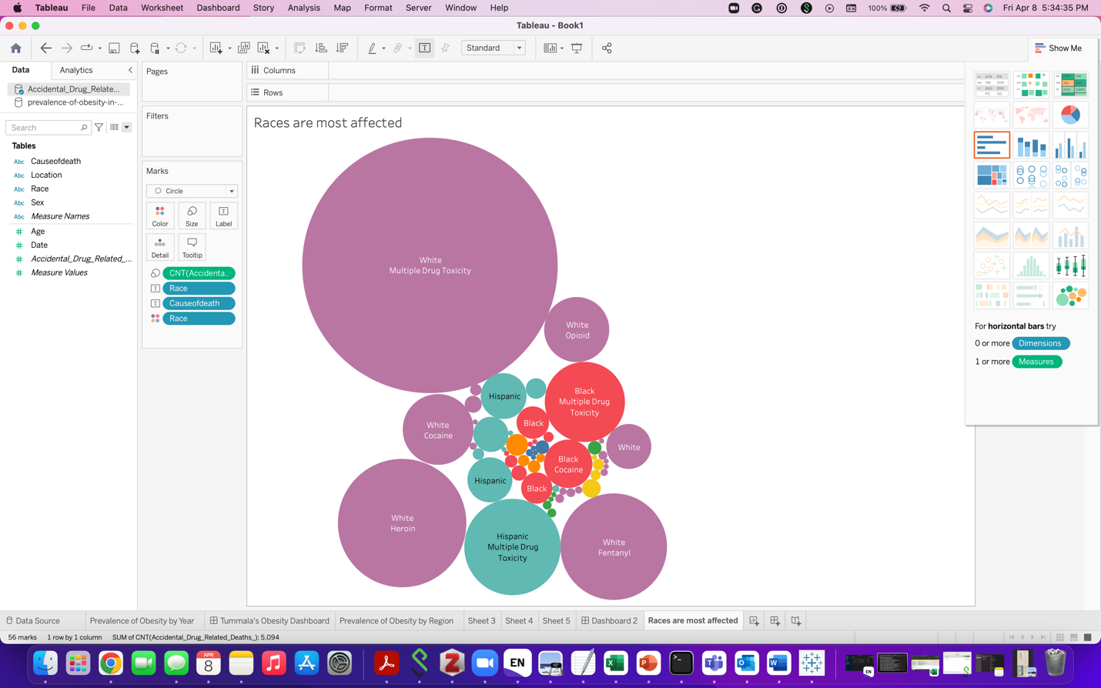

2.2.2 What gender is the most affected?

Males are most effected with Multiple drug toxicity.

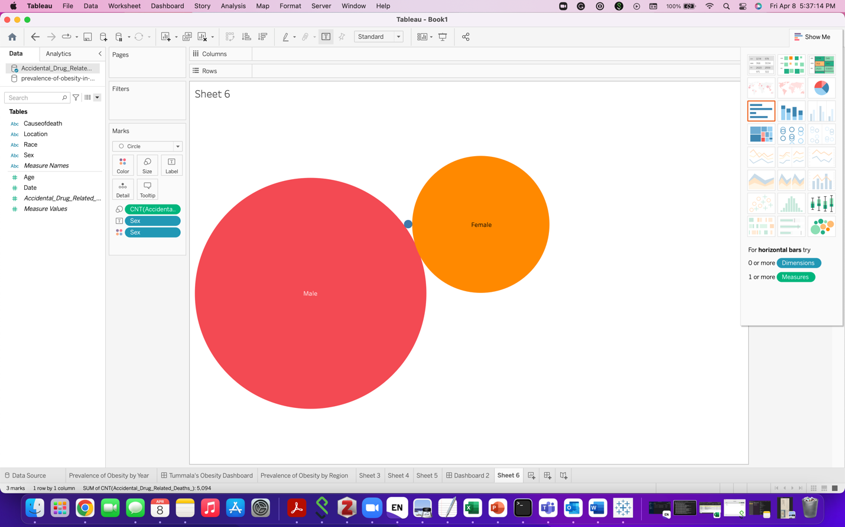

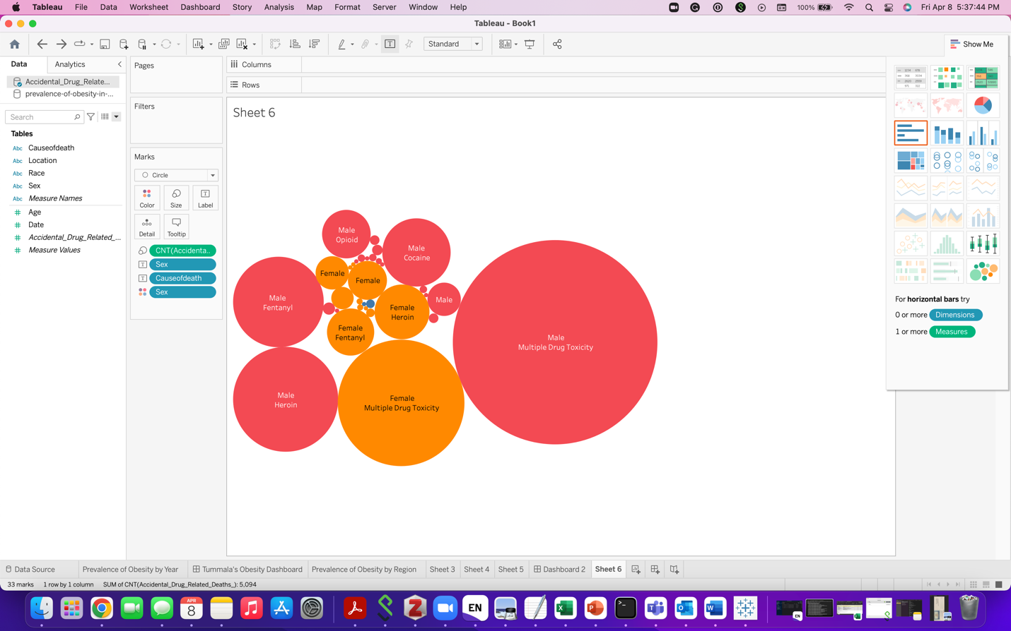

2.2.3 Where do most deaths occur?

Most of the deaths occur at residence (2672).

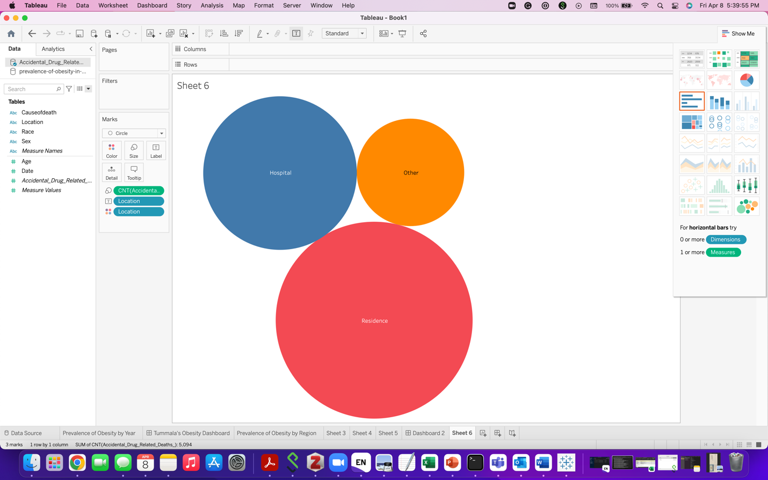

2.2.4What is the overall trend in drug-related deaths?

There is an increase in the count of deaths from 2012 to 2017 but from 2017-2018 there is decrease in the numbers

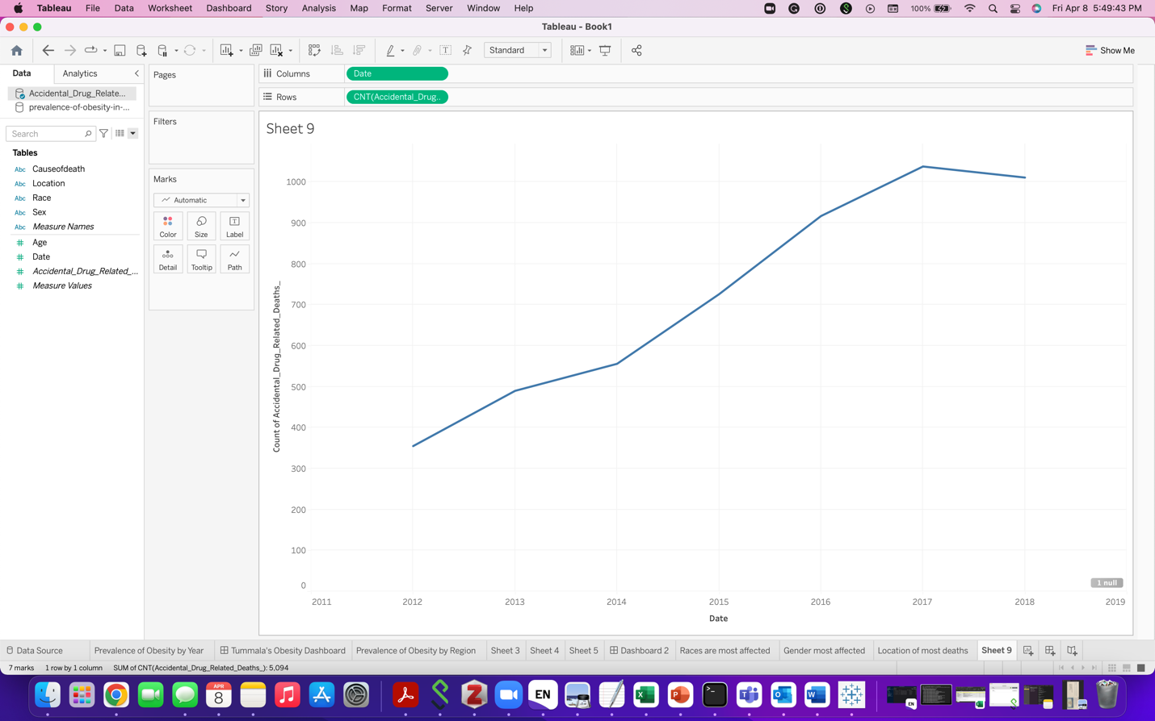

2.3.Provide screenshot of Tableau dashboard with your name as part of the dashboard title.

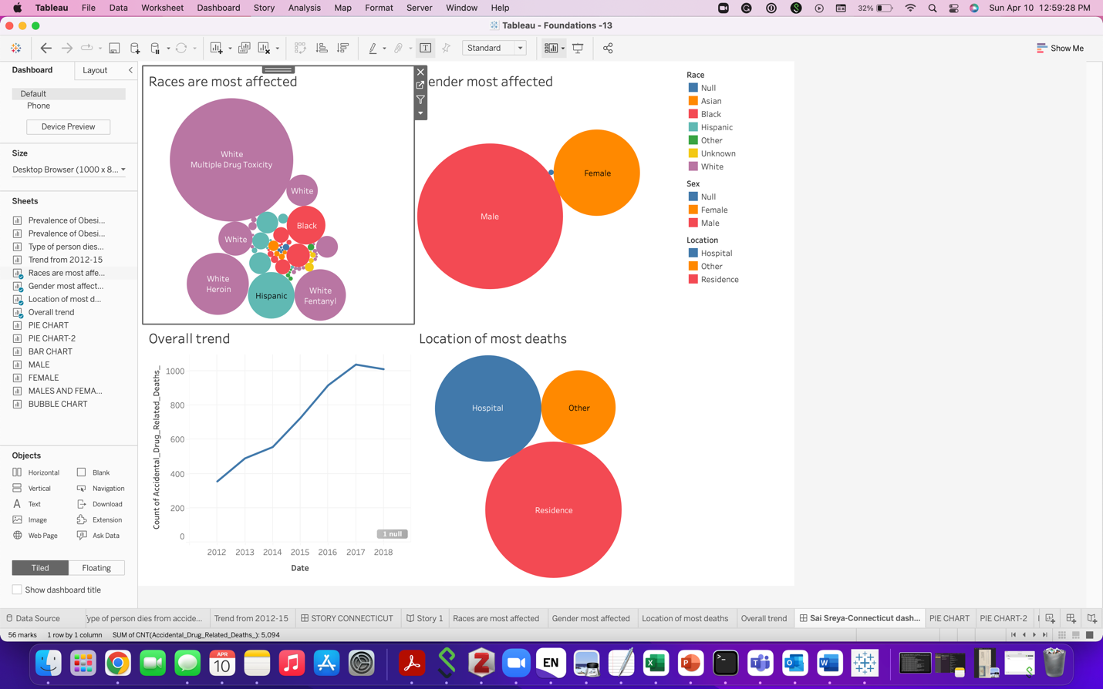

3. 6 CHARTS-TABLEAU

MALES BY AGE CATEGORY

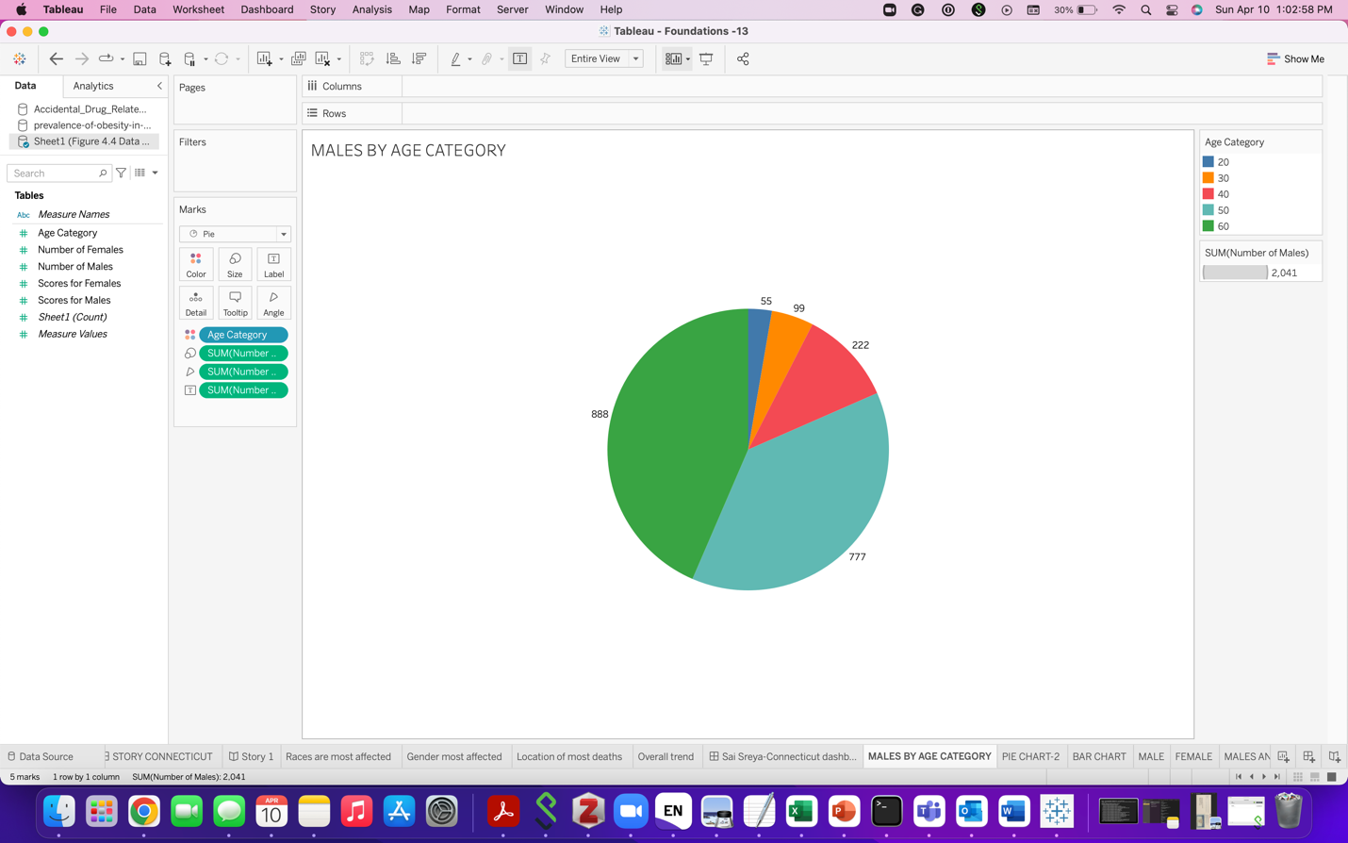

MALES AND FEMALES BY AGE CATEGORY:

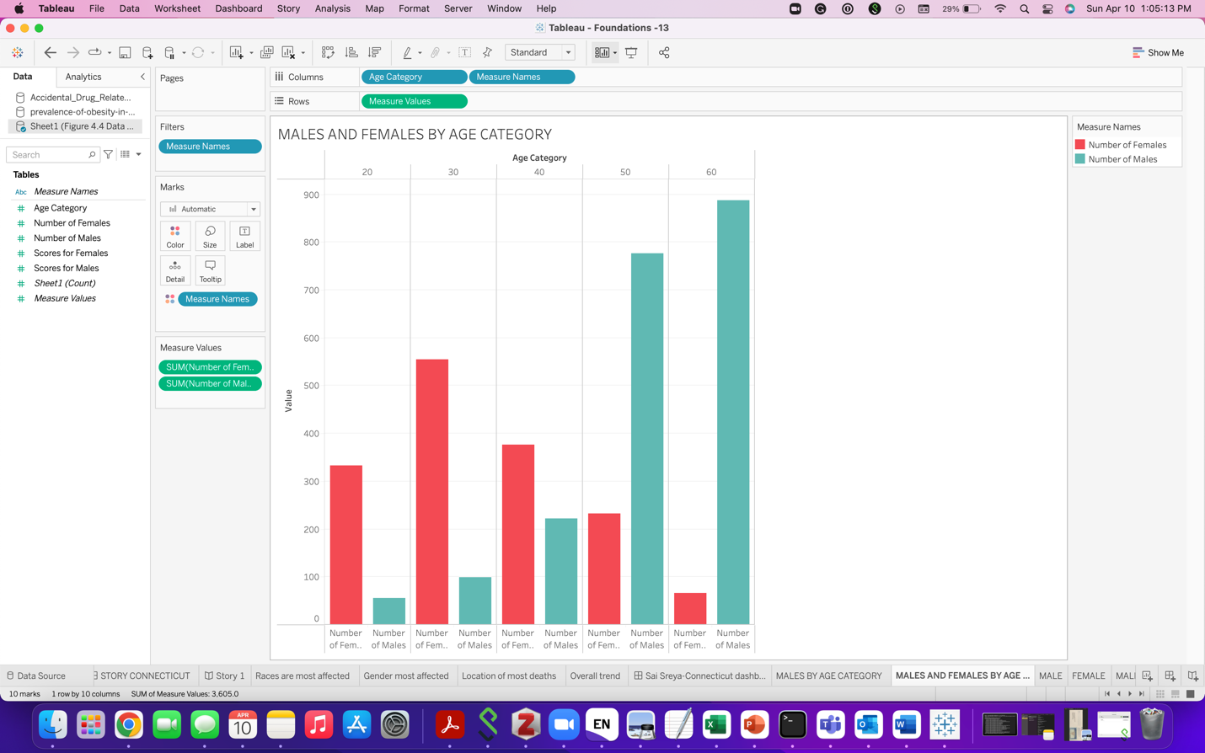

MALES:



FEMALES:



MALES AND FEMALES:



MALES AND FEMALES BY AGE CATEGORY AND SCORE:

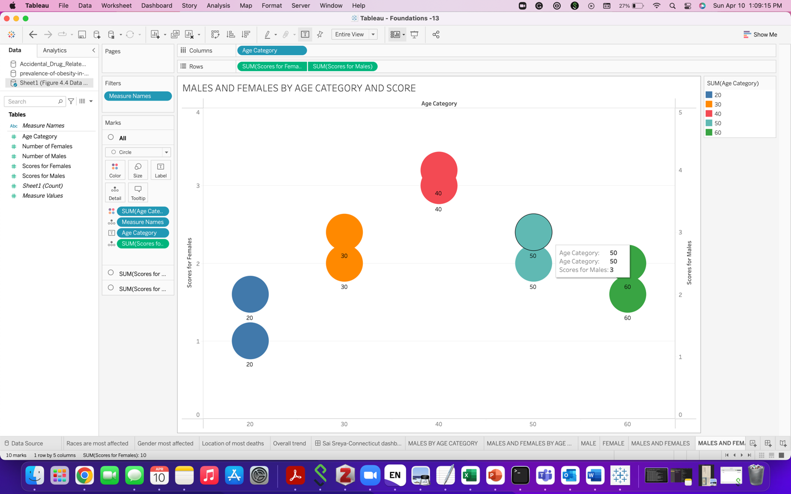

4. 7 CHARTS: EXCEL

HEATMAP

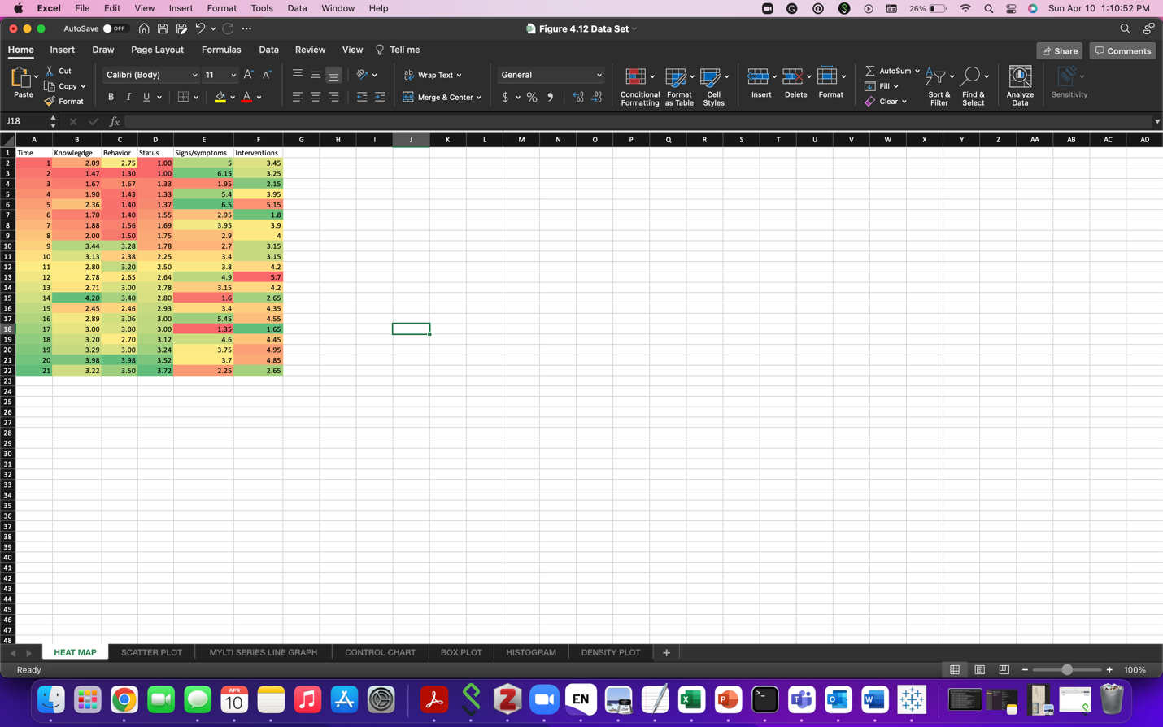

SCATTER PLOT

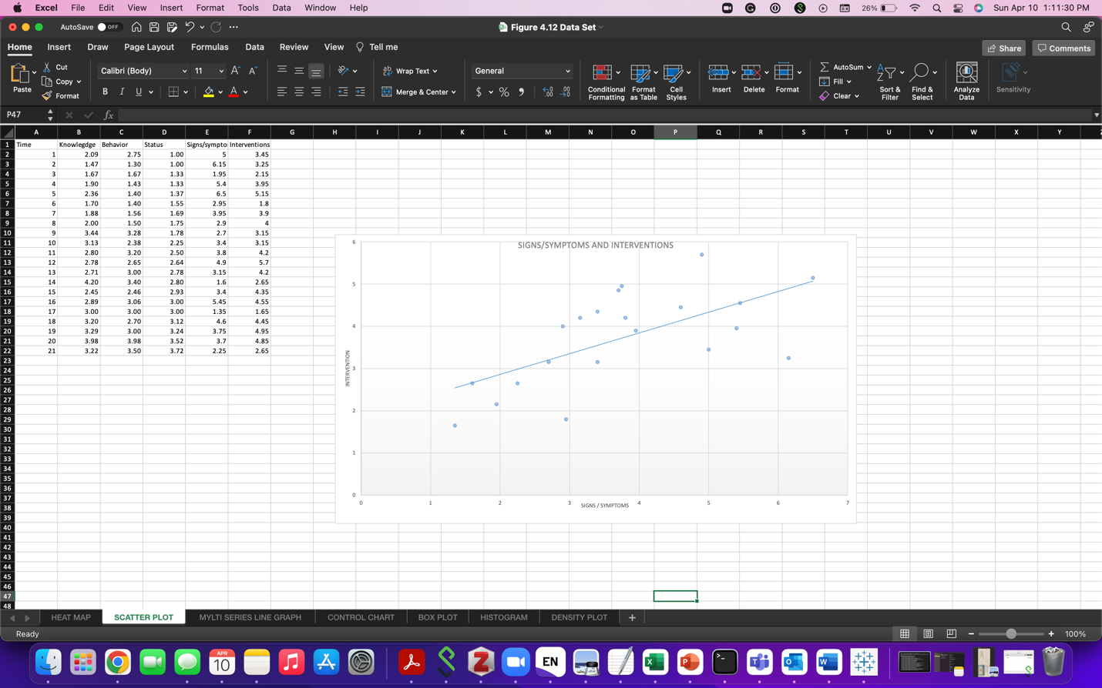

MULTISERIES LINE GRAPH

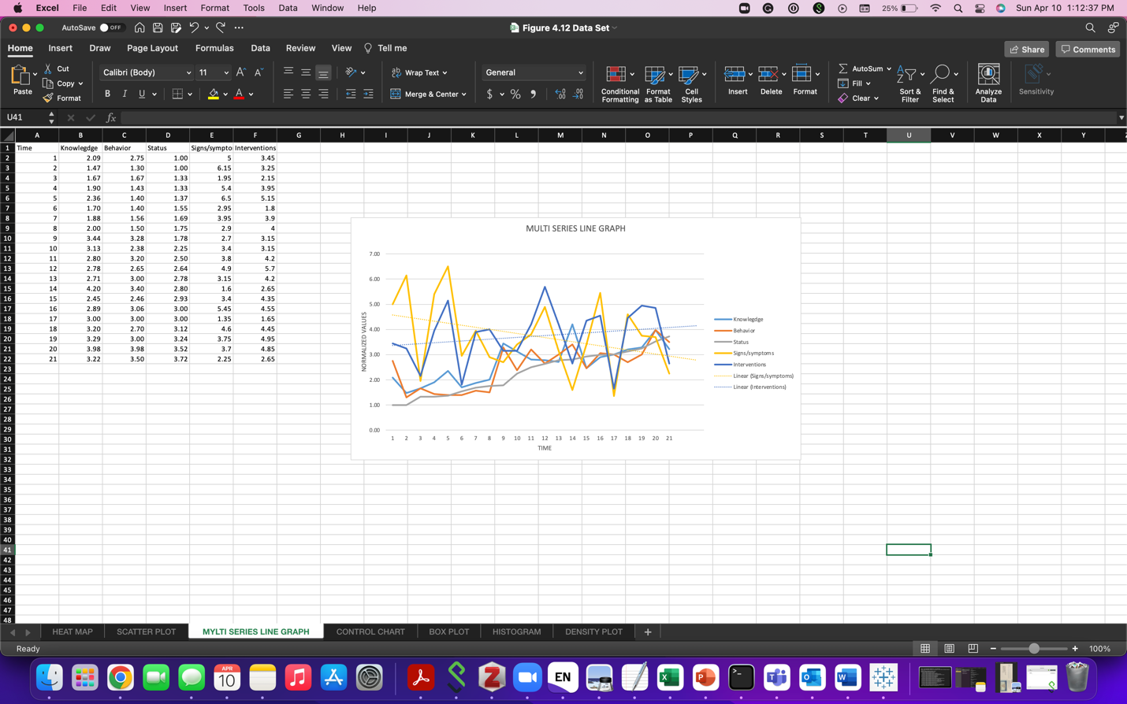

CONTROL CHART

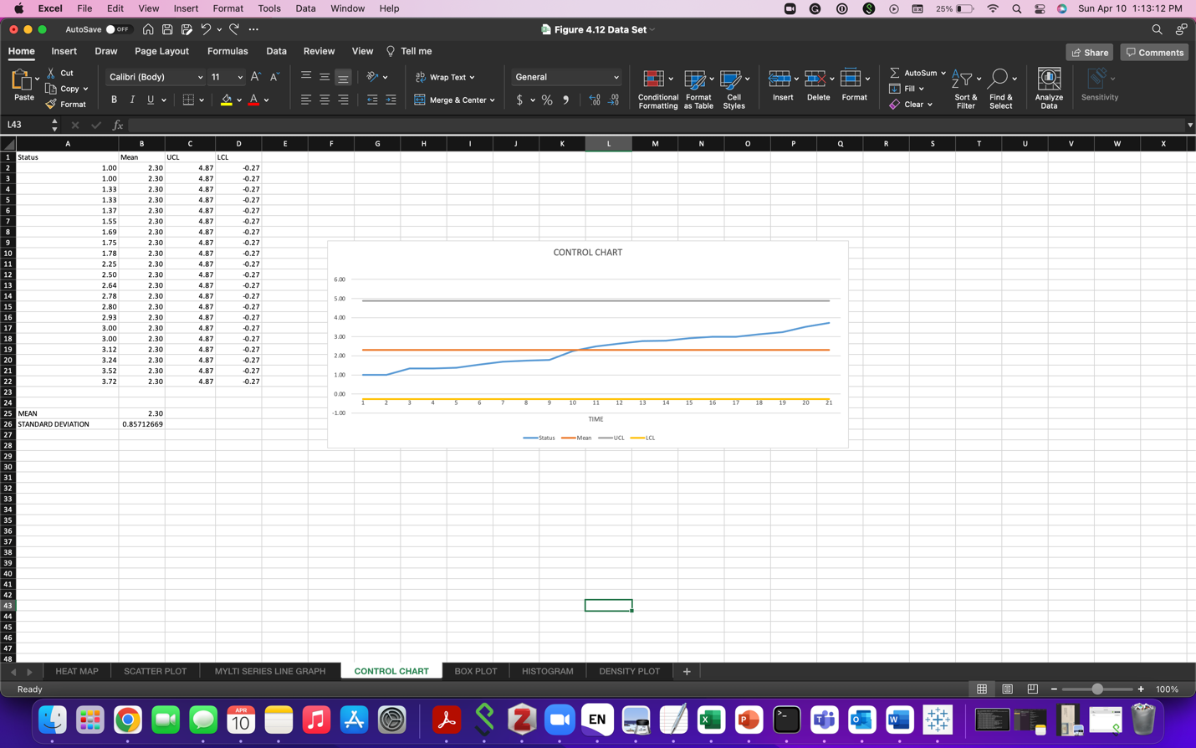

BOX PLOT

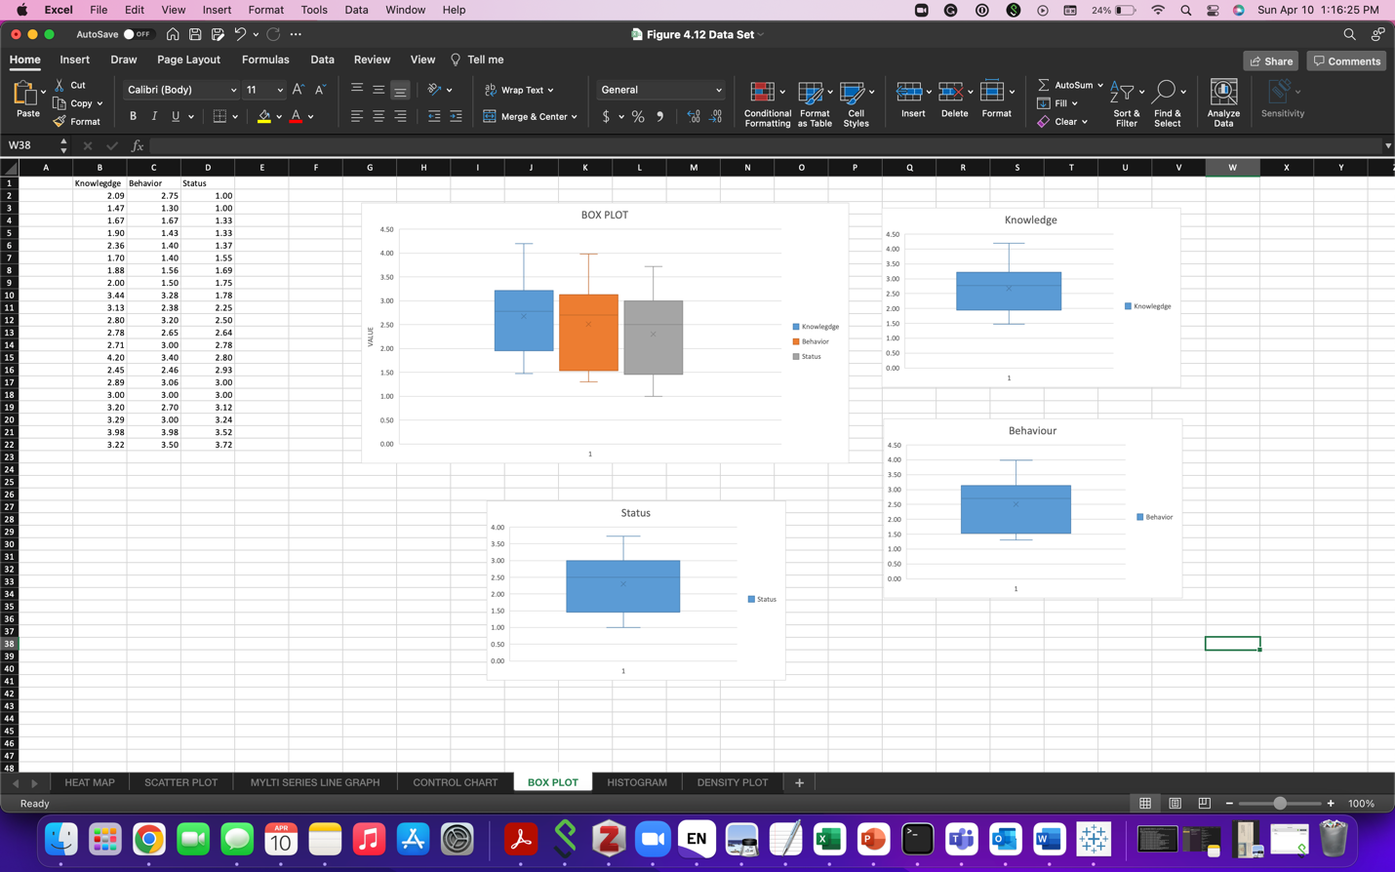

HISTOGRAM

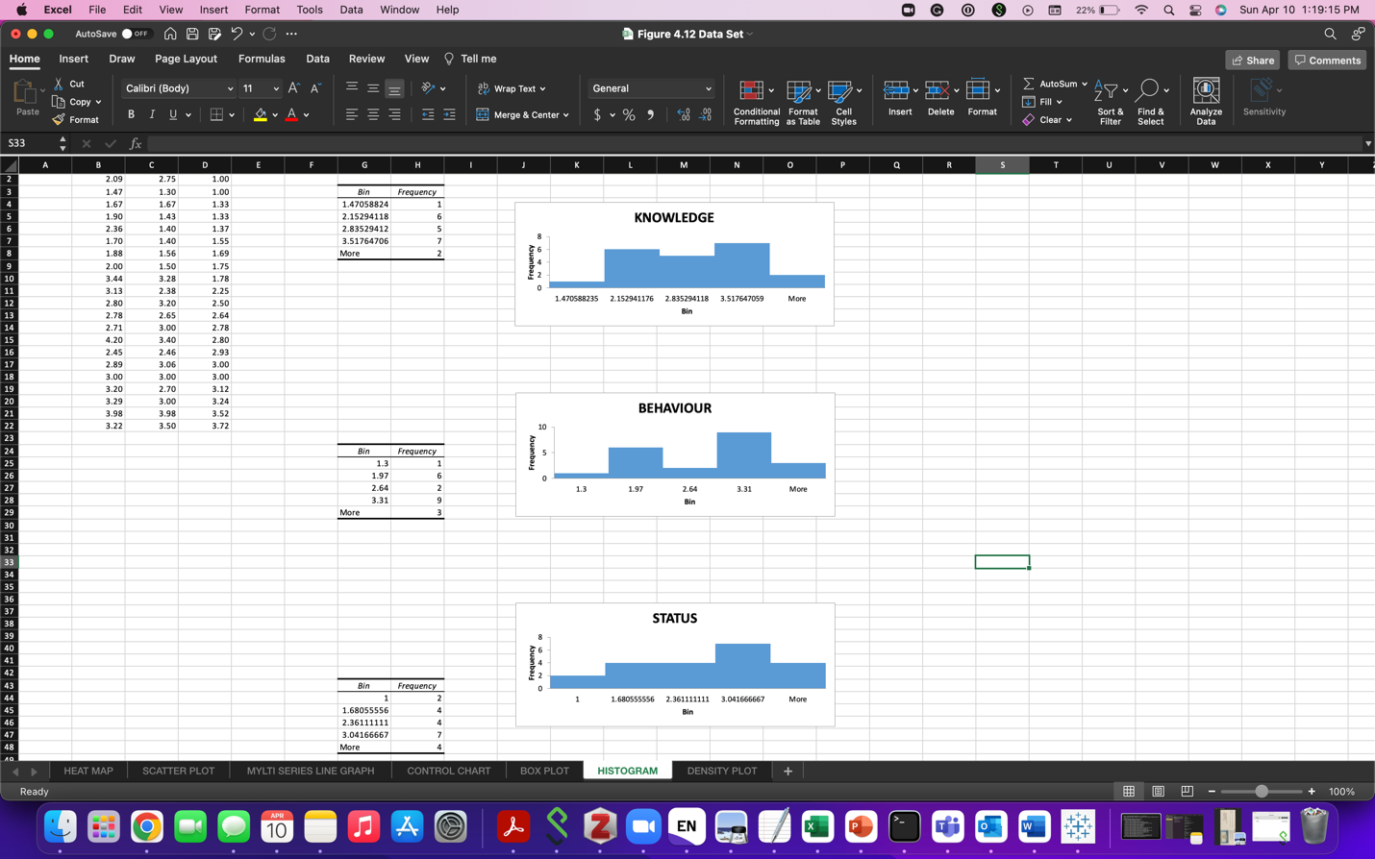

DENSITY PLOT

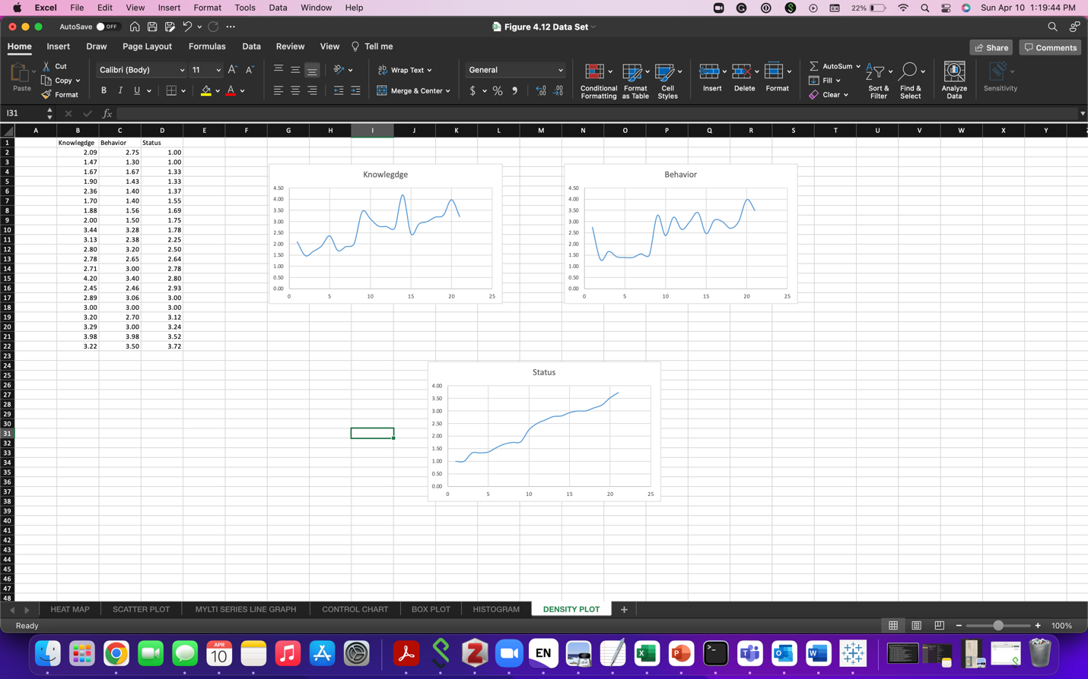

BIG DATA HOMEWORK

1.This article developed a machine learning model which is capable of predicating from the entire raw EHR records using FHIR format and without site specific data harmonization.

When the data is arranged in FHIR format, models become capable to predict multiple medical events at multiple centers without requirement of site-specific data harmonization.

This approach of inclusion of both structed and unstructured healthcare data determined predictions for wide range of clinical problems and outcomes. This also outperformed traditional models by implying hand-selection of variables is not important.

Use of attribution mechanics, training with TensorFlow, very large sample size. To ascertain the potential of 80% sensitivity, the study reported work-up to detection ration, known as number, needed to evaluate. This study outperformed the traditional models in terms of predicting mortality (0.92–0.94 vs 0.91), unexpected readmission (0.75–0.76 vs

0.69), and increased length of stay (0.85–0.86 vs 0.77).

2.1 The primary reason for healthcare data to be different is its diversification. Other reasons like inclusion of structed and unstructured data, rooting back to evidence based practice and continuous evolution of data contribute to its uniqueness.

2.2 Citation:

Dash, S., Shakyawar, S.K., Sharma, M. *et al.* Big data in healthcare: management, analysis and future prospects. *J Big Data* **6,**54 (2019). <https://doi.org/10.1186/s40537-019-0217-0>